Assignment-based Subjective Questions
1. From your analysis of the categorical variables from the dataset, what could you infer about their effect on the dependent variable?
Ans: Count of Bikes increased in year 2019 than year 2018.
Count of Bike rentals is more during clear weather.

2. Why is it important to use drop_first=True during dummy variable creation?
Ans: To avoid redundant features.
To avoid multicollinearity (If we don’t drop, dummy variables will be correlated) and affect the model adversely.

3.Looking at the pair-plot among the numerical variables, which one has the highest correlation with the target variable?
Ans: Count (Target variable) has significantly high correlation with temperature.

4. How did you validate the assumptions of Linear Regression after building the model on the training set?
Ans: Residual error follows normal distribution.
Maintain linear relation between dependent variable(Test and predicted)

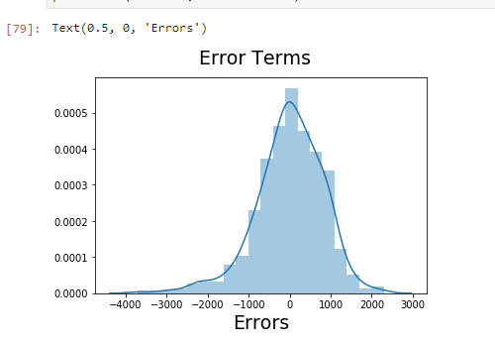

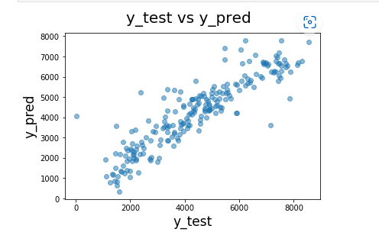
5. Based on the final model, which are the top 3 features contributing significantly towards explaining the demand of the shared bikes?
Ans: Temperature
Weather situation
Year

General subjective questions

1. Explain the linear regression algorithm in detail.
Ans: Linear regression is a machine learning algorithm based on supervised learning.In This algorithm we train a model to predict the behaviour of our data based on some variables.These variables are called independent variables.It is mostly used for finding out the relationship between variables and forecasting.In the case of linear regression as you can see the name suggests linear that means the two variables which are on the x-axis and y-axis should be linearly correlated.
Mathematically, Linear regression is represented by following equation:
y=mx+c
Where m = Slope of the line
c = y-intercept of the line
x = Independent variable from dataset
y = Dependent variable from dataset

2. Explain the Anscombe’s quartet in detail.
Ans: Anscombe’s quartet comprises four datasets that have nearly identical simple statistical properties, yet appear very different when graphed. Each dataset consists of eleven (x,y) points. They were constructed in 1973 by the statistician Francis Anscombe to demonstrate both the importance of graphing data before analyzing it and the effect of outliers on statistical properties.
Simple understanding:
Once Francis John “Frank” Anscombe who was a statistician of great repute found 4 sets of 11 data-points in his dream and requested the council as his last wish to plot those points. Those 4 sets of 11 data-points are given below.
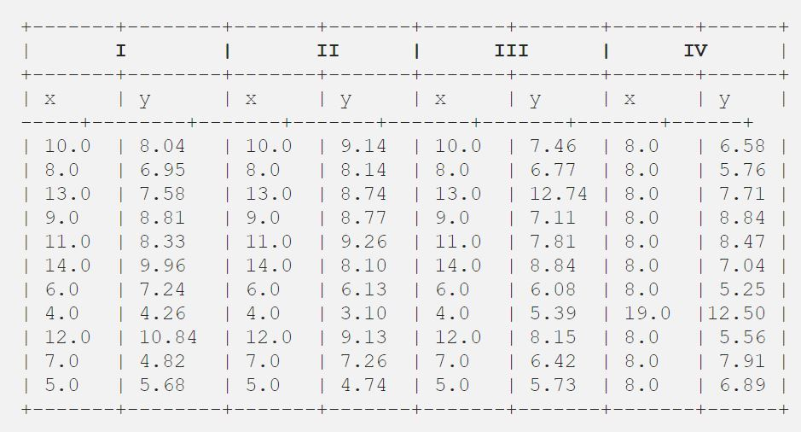
After that, the council analyzed them using only descriptive statistics and found the mean, standard deviation, and correlation between x and y.

3. What is Pearson’s R?
Ans: Correlation measures the strength of association between two variables as well as the direction. There are mainly three types of correlation that are measured. One of them is Pearson's correlation coefficient. This type of correlation is used to measure the relationship between two continuous variables.In statistics, the Pearson correlation coefficient (PCC), also referred to as Pearson's r, the Pearson product-moment correlation coefficient (PPMCC), or the bivariate correlation, is a measure of linear correlation between two sets of data. It is the covariance of two variables, divided by the product of their standard deviations; thus it is essentially a normalised measurement of the covariance, such that the result always has a value between −1 and 1.
The Pearson's correlation coefficient varies between -1 and +1 where:
- r = 1 means the data is perfectly linear with a positive slope ( i.e., both variables tend to change in the same direction)
- r = -1 means the data is perfectly linear with a negative slope ( i.e., both variables tend to change in different directions)
- r = 0 means there is no linear association
- r > 0 < 5 means there is a weak association
- r > 5 < 8 means there is a moderate association
- r > 8 means there is a strong association
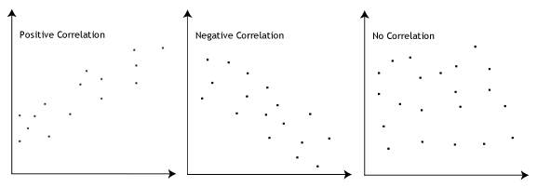
4. What is scaling? Why is scaling performed? What is the difference between normalized scaling and standardized scaling?
Ans: It is a step of data Pre-Processing which is applied to independent variables to normalize the data within a particular range. It also helps in speeding up the calculations in an algorithm.
As sometimes the collected data set contains features highly varying in magnitudes,units and range.If scaling is not performed then it will only take magnitude into consideration and not units and that will be incorrect modelling.We do scaling to bring all the variables to same level of magnitude.

S.NO. | Normalisation | Standardisation
1. | Minimum and maximum value of features are used for scaling | Mean and standard deviation is used for scaling.
2. | It is used when features are of different scales. | It is used when we want to ensure zero mean and unit standard deviation.
3. | Scales values between [0, 1] or [-1, 1]. | It is not bounded to a certain range.
4. | It is really affected by outliers. | It is much less affected by outliers.

5. You might have observed that sometimes the value of VIF is infinite. Why does this happen?
Ans: VIF is an index that provides a measure of how much the variance of an estimated regression coefficient increases due to collinearity. In order to determine VIF, we fit a regression model between the independent variables.
It is calculated by taking the the ratio of the variance of all a given model's betas divide by the variance of a single beta if it were fit alone.
If all the independent variables are orthogonal to each other, then VIF = 1.0. If there is perfect correlation, then VIF = infinity. A large value of VIF indicates that there is a correlation between the variables.

6. What is a Q-Q plot? Explain the use and importance of a Q-Q plot in linear regression.
Q-Q Plots (Quantile-Quantile plots) are plots of two quantiles against each other. A quantile is a fraction where certain values fall below that quantile. For example, the median is a quantile where 50% of the data fall below that point and 50% lie above it. The purpose of Q Q plots is to find out if two sets of data come from the same distribution. A 45 degree angle is plotted on the Q Q plot; if the two data sets come from a common distribution, the points will fall on that reference line.
A Q Q plot showing the 45 degree reference line:
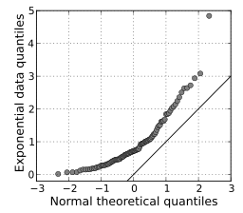
If the two distributions being compared are similar, the points in the Q–Q plot will approximately lie on the line y = x. If the distributions are linearly related, the points in the Q–Q plot will approximately lie on a line, but not necessarily on the line y = x. Q–Q plots can also be used as a graphical means of estimating parameters in a location-scale family of distributions.
A Q–Q plot is used to compare the shapes of distributions, providing a graphical view of how properties such as location, scale, and skewness are similar or different in the two distributions.

